**HNBA**

**Automated commissions**

**&**

**Incentive management system**

**System Requirements Specification – (28-09-2017)**

Version 1.03

Table of Contents

1. Revision History 3
2. Introduction 3

Purpose 3

1. Overall Description 4

**3.1. Background** 4

3.1.1. Agent and Banc Assurance Management Process 4

3.1.2. Commission Calculation Process 5

3.1.2.1. Commission Calculate Rate Chart 7

3.1.2.2. Commission Calculate Rate Chart - Alternative 8

3.1.3. Overriding Commission Calculation Process 9

3.1.3.1 Overriding Commission Calculation Chart 10

3.1.4. Incentive Management Process 11

3.1.4.1. Banc assurance incentive process 11

3.1.4.2. Field Staff Incentive Process 12

3.1.4.3. FST allowance and target allowance 13

Group path level procedure GL/TL/AFM 14

Group path level procedure FM/AGFM/GFM 15

Group path level procedure SGFM 16 3.1.4.4. Group Incentive Criteria 17

3.1.4.5. Retainer Bonus GL/TL/AFM/FM/AGFM/ GFM/SGFM 18-19

**3.2 Objectives** **20**

3.2.1 Design Diagrams 20

3.2.1.1. Flow Chart 20

3.2.1.1.1. Agent and Banc Assurance Management 20

3.2.1.1.2. Data Gathering for Commission 21

3.2.1.1.3. Commission Calculation 22

3.2.1.1.4. Commission Overriding 23

3.2.1.2. User Interface Designs 24

3.2.1.2.1. Agent Personal Detail 24

3.2.1.2.2. Agent Other Detail 25

3.2.1.2.3. Agent Level Detail 26

3.2.1.2.4. Agent Commission / Commission Overriding Detail 27

3.3. Reports 28

3.4. System Integration 29

3.5. Unsolved issues 30

3.6. Assumptions 31

3.7. Annexures………………………………………………………………………………………………………………………… 32

# 1. Revision History

|  |  |  |  |
| --- | --- | --- | --- |
| Date | Version | Description | Author |
| 27/03/2017 | 1.00 | SRS | Janaka Indrajith  Suranga Kulawardane |
| 26/06/2017 | 1.01 | Both Incentive and commission system changes | Janaka Indrajith  Suranga Kulawardane |
| 19/09/2017 | 1.02 | Commission Process – Data transferring mechanism alterations like refunds TCS / Non TCS and reversals. | Janaka Indrajith  Suranga Kulawardane |
| 19/09/2017 | 1.03 | Data upload mechanisms for Oracle & Commission payroll systems | Janaka Indrajith  Suranga Kulawardane |

# 2. Introduction

## Purpose

The idea of this SRS is to finalize the requirement for new commission & Incentive processes for the purpose of automate manual process as much as possible and introduce new features such as dynamic agent hierarchy defining, More validations, New required reports etc..

# 3. Overall Description

## 3.1. Background

Currently HNBA commission system is using by the Finance & Marketing departments. Marketing staff is used to maintain agent management module & Life support service unit is maintaining the Commission module.

* + 1. **Agent and Banc Assurance Maintain Process**

In this process we are keeping all the details of Agents and Banc Assurance such as personal details, Educational details, Commission details, Retainer details, Incentive details etc…

Agent maintain process will start just after marketing staff got a physical file which contain agent details. After receiving the file they should feed the same agent details to TCS application as well BISCoa application but only BISCoa data is used to maintain the agent module and commission module.

Since there are agent hierarchy maintain limitations, Manual uploads and system maintain difficulties we have decided to implement this new application with a dynamic way by considering the new features and system enhancements requested.

In here especially we have considered agent reporting hierarchy module with both vertically and horizontally defining.

* + 1. **Commission Calculation Process**

A commission is a form of payment to an agent in which the agent receives a percentage of the value of each transaction that a client makes.

According to the discussions, we have decided to calculate commissions up to cover level currently it is up to product level. Cover level commission supposed to calculate after the normal commission calculation since this is an addition commission. Please refer the processes to be implemented.

**Receipts** - Transfer Daily TCS receipts to Commission Application and currently there is an automated

Process for this so we too using the same process for this. In the meantime BIS system Dollar receipts also transfer to commission application through a back end process.

**Sys Vouchers** - Transfer sys vouchers from TCS to commission system, since daily basis income transfer also happening there. Furthermore policy fee and renewal policy fee transfer to commission system according to the Transfer type such as (FST / FYP / RNW). And sys vouchers relating to the policy fee, which is borne by tolerance, should also be transferred to new commission system. Especially when we transfer TCS Sys vouchers we are checking Commission system’s PID balance availability too.

Note - All above are new processes

**Refunds (TCS)** –

As a validation, at any given time PID balance of both systems (TCS & NEW COMMISSION SYSTEM) should be equal, before and after processing the refund. If the TSC and NEW COMMISSION SYSTEM PID balances are not in line, refunds should be blocked.

* + - All refunds should be processed from PID only.
    - Avoid receipt number and receipt amount feeding in TCS, since there is no technical reason for the Life Department to specify receipts, at the time of creating the refund.
    - For Income Refunds, adequate number of income cycles which is equal or more than the refunding amount, should be reversed in TCS(should be the latest payment cycle) and money should be transferred to the PID. Relevant SYS voucher should be transferred to NEW COMMISSION SYSTEM. Such Payment Cycle Reversals (Transfer Type) in NEW COMMISSION SYSTEM should be in line with TCS and NEW COMMISSION SYSTEM PID balances should be equal.

Once the Refund is approved in TCS, TCS Refund PV should be pushed to NEW COMMISSION SYSTEM. NEW COMMISSION SYSTEM should automatically specify/allocate the latest receipts and such receipt should be marked as refunded in NEW COMMISSION SYSTEM. As a result at any given scenario, Receipt or Payment Cycle reversal/refund should be commenced from the Latest (Last in First Out).

Those automatically specified receipts should be updated to a workflow/new tab in NEW COMMISSION SYSTEM, through which Bank Reconciliation Team could confirm the realization. (IBT & Cheques)

Once realization is confirmed

* + - Commission relating to the Payment Cycle Reversed, should be recovered from the relevant Advisor.
    - Refund Advise should be pushed to CPS, through the NEW COMMISSION SYSTEM after updating the relevant receipts and ensuring the realization.  Current process for refund payments is to directly push data to CPS from TCS. BISCOA update and realization check is done manually.

**Note: - This explanation is not directly related to commission system, but we are providing a screen with list of refunds for the relevant party confirmation and then we are able to process this refunds.**

**Refunds (Non TCS)** - New Interface for user to do manual refunds and upload the DPTS. Same realization

Process should apply here as mentioned above.

**Cancellations / Cheque Returns –**

Process is identical to the Refund Process

* If the concerned receipt is in the PID of both TCS and NEW COMMISSION SYSTEM and the balances are inline,
  + Cancellation/Cheque Return should be updated in NEW COMMISSION SYSTEM.
* If the relevant receipt is already transferred to income, payment cycle reversal sys voucher (which is generated in TCS and should be the latest payment cycle) should be pushed to NEW COMMISSION SYSTEM and the relevant (latest) premium update in NEW COMMISSION SYSTEM should also be reversed (Transaction Type of TCS and NEW COMMISSION SYSTEM should be identical) and money should be transferred to PID. If the PID balance of both TCS and NEW COMMISSION SYSTEM are inline,
  + Cancellation/Cheque Return should be updated in NEW COMMISSION SYSTEM.
  + Commission relevant to the reversed premium/transaction type (latest payment cycle) should be reversed and recovered from the relevant advisor.

There should be no outward payment (nothing should be pushed to CPS), and receipt which is in PID should be marked as cancelled or Cheque Returned.

**Process – NonTCS DPTS -** Manually upload excel files in to the commission system and if there are any systems available we are trying to get data from those databases.

**Process - write-off -** Manually upload write-off excel file and then view finance staff for their confirmation and update the PID balance as well as receipts amounts accordingly.

**Commission Process -** Then calculate the commission according to the given rates through the rule interface.

**OR Commission Process -** Then calculate the overriding commission according to the given rates through the overriding rule interface for both horizontal and vertical.

**OR Commission Process -** Then calculate the overriding commission according to the given rates through the overriding rule interface.

**Accrued Commission Process -** Calculate the commission same as normal commission calculation and the take the difference between should transferred and the Real Transferred.

**Data process with Payroll system –** At present Payroll system retrieving data from BISCoa tables. Also we are planning to maintain web services to provide data on request.

**Income & Commission data Upload to Oracle system –** At present manually feed data to oracle based on summery report in BISCoa and also we are able to provide excel data if you need with given format by you.

* + - 1. **Commission Calculation Rate Chart**

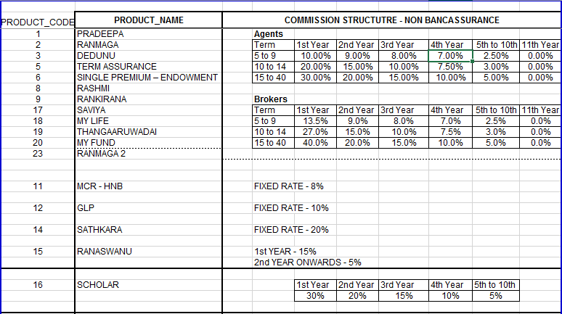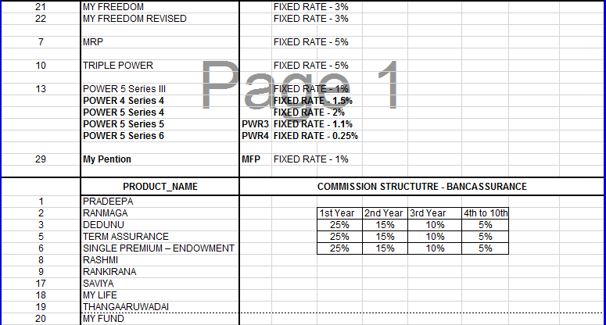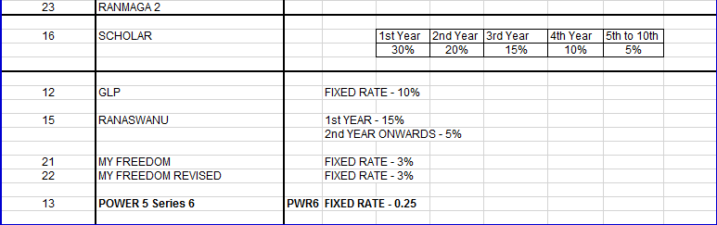

* + - 1. **Commission Calculation Rate Chart - Alternative**

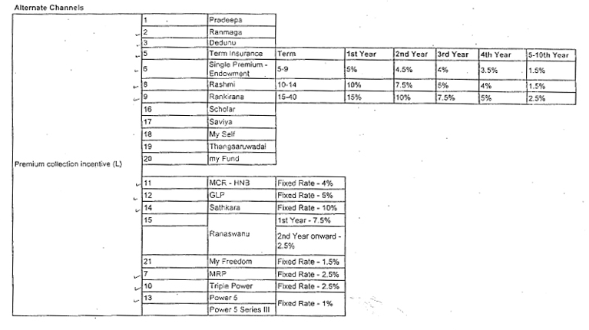

* + 1. **Overriding Commission Calculation Process**

An extra or additional commission, which paid to an agent or broker on business sold by subagents in his or her territory.

This happens from individual level to group level (E.g. from Field Advisor to GL or TL). In between individual level no overriding take place. Also there are some levels which cannot assign for overriding, system allows to configure those levels (Eg.GL to TL) and there is something called GAP which means overriding commission happens by passing levels.

With this module we are maintaining the hierarchy both horizontal and vertical because Some people has to wait long time to get a promotion because of their reporting level won’t allow since if they allow that they will miss the commission from the promoted party. So then even after the promotion we can assign a portion of the commission from promoted party to their previous superior.

* + - 1. Commission overriding rate chart

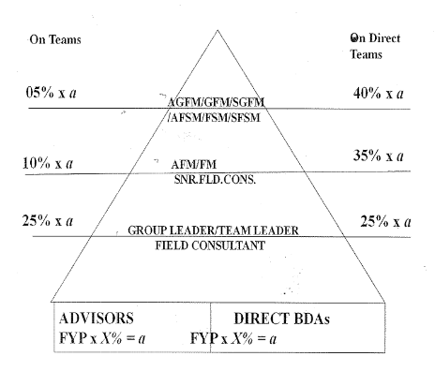

Example for proposed Commission overriding feature in graphically

According to the example GL or TL getting overriding commission from advisor as usual then the advisor promote to individual level (FC / AFC) after this GL/TL will not have overriding anymore as a solution for this we are implementing a feature for that GL/TL still can have some percentage of overriding commission. (Percentage still not decided)

?

FC / AFC etc…

GL/TL etc…

Promotion Current Overriding

Advisor

* + 1. **Incentive Management process**

Basically there are two incentive methods named as Bank Assurance & Field Staff incentives. In the Bank Assurance incentive method currently there are two incentive schemes as follows. As well as field staff incentive process can bifurcate such as Individual and Group paths. Under these two categories there are allowance types such as FST allowance, Target allowance, Retainer allowance, Advisor development allowance etc… also there are some defined levels such as GL, TL, SFC, FC, FSM and by considering all those given Categories, Allowance Types, Levels there are several calculation tables which is describing under the Field Staff incentives.

* + - 1. **Bank Assurance Incentive Process**

1. Incentive scheme for BAO’s

* Minimum achievement of NOP for the month 3, 4, 5 etc…
* Compulsory except for BAO’s less than one year

|  |  |
| --- | --- |
| NBP (FST + FYP) | Reimbursement of Business expenses |
| Achievement 80% - 100% | 1% of the NBP Achievements |
| Achievement 100% - 110% | 2% of the NBP Achievements |
| Achievement 110% - 120% | 3% of the NBP Achievements |
| Achievement 120% & Above | 4% of the NBP Achievements |

1. Incentive scheme for Executive

10% overriding commission of the attached BAO’s incentives in the respective cluster in addition to receivable from their own branches.

**3.1.4.1. Field Staff Incentive Process**

Allowances Types can categorize as follows

* Individual
  + FST Allowance - Monthly Payment
  + Target Allowance - Yearly Payment
* Group
  + Retainer Allowance - Monthly Payment
  + Retainer bonus allowance - Yearly Payment
  + Retainer arrears - Yearly Payment
  + Advisor development allowance - Monthly Payment
  + Group achievement - Monthly Payment

**Individual**  **Group**

Senior Group Field Manager

Senior Financial Services Manager

Group Field Manager

Financial Services Manager

Assistant Group Field Manager

Assistant Financial Services Manager

Field Manager

Senior Field Consultant

Assistant Field Manager

Field Consultant

Senior Field Executive

Senior Insurance Advisor

Field Executive

Insurance Advisor

Senior Insurance Advisor

Insurance Advisor

* + - 1. **FST Allowance (Individual)**

Advisors who are within 1st year from the date of appointment will get a FST allowance on a monthly basis, Maximum allowance will be Rs. 2500 (Configurable). After one year of the service period they will continue to enjoy the existing Target allowance.

|  |  |  |  |
| --- | --- | --- | --- |
| **No** | **Policies** | **FST Amount** | **FST Allowance** |
| 1 | 2 | <5000 | 750 |
| 2 | 2 | <7500 | 1000 |
| 3 | 2 | <10000 | 1250 |
| 4 | 2 | <12500 | 1500 |
| 5 | 2 | <15000 | 1750 |
| 6 | 2 | <25000 | 2500 |

* + - 1. **Target Allowance (Individual)**

|  |  |  |
| --- | --- | --- |
| **For the Month** | **Rs.** | **Allowance Rs.** |
| On Achieving MCFP | 7500 | 1000 |
| Additional MCFP | 2500 | 250 |
| FYP of | 25000 | 1000 |
| Addition FYP of | 10000 | 500 |

* Insurance advisor & Senior Insurance Advisor

|  |  |
| --- | --- |
| Insurance Advisor | Rs. 480000 |
| Senior Insurance Advisor | Rs. 720000 |

* Field Consultant

Annual New Business Premium (NBP) Target – 1.5M.

* Senior Field Consultant

Annual New Business Premium (NBP) Target – 2.0M.

* Assistant Financial Service Manager

Annual New Business Premium (NBP) Target – 3.0M.

* Financial Service Manager

Annual New Business Premium (NBP) Target – 4.0M.

* Senior Financial Service Manager

Annual New Business Premium (NBP) Target – 5.5M.

* + - 1. **Group Path Level Procedure**

Field Executive - GL

* Retainer allowance will base on monthly and cumulative achievement and will be paying the allowance on every month end. Maximum allowance will be Rs.6500/-.
* Retainer Bonus will be paying on every year end base on the highest achievement, maximum bonus will be Rs. 70200/-.
* Advisor development allowance will be 2500/-.

Senior Field Executive - TL

* Retainer allowance will base on monthly and cumulative achievement and will be paying the allowance on every month end. Maximum allowance will be Rs.9500/-.
* Retainer Bonus will be paying on every year end base on the highest achievement, maximum bonus will be Rs. 102600/-.
* Advisor development allowance will be 3500/-.

Assistant Field Manager (AFM)

* Retainer allowance will base on monthly and cumulative achievement and will be paying the allowance on every month end. Maximum allowance will be Rs.12000/-.
* Retainer Bonus will be paying on every year end base on the highest achievement, maximum bonus will be Rs. 129600/-.
* Advisor development allowance will be 4000/-.
* Group achievement allowance will base on cumulative group NBP achievement, maximum allowance will be Rs.8000/-.

Field Manager (FM)

* Retainer allowance will base on monthly and cumulative achievement and will be paying the allowance on every month end. Maximum allowance will be Rs.15000/-.
* Retainer Bonus will be paying on every year end base on the highest achievement, maximum bonus will be Rs. 129600/-.
* Advisor development allowance will be 5000/-.
* Group achievement allowance will base on cumulative group NBP achievement, maximum allowance will be Rs.9000/-.

Assistant Group Field Manager (AGFM)

* Retainer allowance will base on monthly and cumulative achievement and will be paying the allowance on every month end. Maximum allowance will be Rs.18000/-.
* Retainer Bonus will be paying on every year end base on the highest achievement, maximum bonus will be Rs. 194400/-.
* Advisor development allowance will be 6000/-.
* Group achievement allowance will base on cumulative group NBP achievement, maximum allowance will be Rs.10000/-.

Group Field Manager (GFM)

* Retainer allowance will base on monthly and cumulative achievement and will be paying the allowance on every month end. Maximum allowance will be Rs.22000/-.
* Retainer Bonus will be paying on every year end base on the highest achievement, maximum bonus will be Rs. 237600/-.
* Advisor development allowance will be 7000/-.
* Group achievement allowance will base on cumulative group NBP achievement, maximum allowance will be Rs.11000/-.

Senior Group Field Manager (SGFM)

* Retainer allowance will base on monthly and cumulative achievement and will be paying the allowance on every month end. Maximum allowance will be Rs.25000/-.
* Retainer Bonus will be paying on every year end base on the highest achievement, maximum bonus will be Rs. 270000/-.
* Advisor development allowance will be 8000/-.
* Group achievement allowance will base on cumulative group NBP achievement, maximum allowance will be Rs.13000/-.

## Group Incentive Criteria

## 

## 

## Retainer Bonus

* Only Direct Team NBP Achievement applicable for this

|  |  |  |  |  |  |  |
| --- | --- | --- | --- | --- | --- | --- |
| GL | Achievement % | 110-124.99 % | 125-149.99 % | 150-174.99 % | 175- 200 % | >200% |
|  | Bonus | 9000 | 15000 | 30000 | 58500 | 70200 |

|  |  |  |  |  |  |  |
| --- | --- | --- | --- | --- | --- | --- |
| TL | Achievement % | 110-124.99 % | 125-149.99 % | 150-174.99 % | 175- 200 % | >200% |
|  | Bonus | 17100 | 28500 | 57000 | 85500 | 102600 |

|  |  |  |  |  |  |  |
| --- | --- | --- | --- | --- | --- | --- |
| AFM | Achievement % | 110-124.99 % | 125-149.99 % | 150-174.99 % | 175- 200 % | >200% |
|  | Bonus | 21600 | 36000 | 72000 | 108000 | 129600 |

|  |  |  |  |  |  |  |
| --- | --- | --- | --- | --- | --- | --- |
| FM | Achievement % | 110-124.99 % | 125-149.99 % | 150-174.99 % | 175- 200 % | >200% |
|  | Bonus | 27000 | 45000 | 90000 | 135000 | 162000 |

|  |  |  |  |  |  |  |
| --- | --- | --- | --- | --- | --- | --- |
| AGFM | Achievement % | 110-124.99 % | 125-149.99 % | 150-174.99 % | 175- 200 % | >200% |
|  | Bonus | 32400 | 54000 | 108000 | 162000 | 194400 |

|  |  |  |  |  |  |  |
| --- | --- | --- | --- | --- | --- | --- |
| GFM | Achievement % | 110-124.99 % | 125-149.99 % | 150-174.99 % | 175- 200 % | >200% |
|  | Bonus | 39600 | 66000 | 132000 | 198000 | 237600 |

|  |  |  |  |  |  |  |
| --- | --- | --- | --- | --- | --- | --- |
| SGFM | Achievement % | 110-124.99 % | 125-149.99 % | 150-174.99 % | 175- 200 % | >200% |
|  | Bonus | 45000 | 75000 | 150000 | 225000 | 270000 |

## 3.2 Objectives

### 3.2.1 Design Diagrams

#### 3.2.1.1. Flow Chart

3.2.1.1.1. Flow chart 01 - Defines the main process of agent and Banc Assurance management module

**Agent Process** **Banc Assurance Process**

Start

Start

Get details From HR system

View Agent File

Update BAO details

Update Agent personal / other details

End

Update Agent level details

Update Agent ISS, Retainer Details, Terminations, Transfer Branches, Leader given dates etc…

End

3.2.1.1.2. Flow chart 02 – Define the process of data gathering for commission calculation

Start

For the month Transferred Sys Vouchers

For the month Cheque returns, reversals, Cancellations

For the month Manual receipts

For the month TCS receipts

For the month opening balance

PID List

Proposal number updates by policy no (Using Unadjusted Report)

Update Cheque returns/Refunds/ Reversals/ Cancellation

Update Sys vouchers

Update PID Balance

Check matching Receipts

Commission calculation with transaction codes (FST/FYP/RNW)

Yes

No

End

3.2.1.1.3. Flow chart 03 – Define the process of commission calculation

Commission calculation with transaction codes (FST/FYP/RNW)

Get Date Range for promotions and separate rate charts

Get Agent Type Detail – Agent / Broker

Get Term Detail – 5-9/10-14/15-40

Get Time Slab – 1st year / 2nd year

Get BA / NBA

Get Product Code Detail – Pradeepa/Ranmaga



Get Risk Detail – Spouse / Child

Get Cover Detail – TPPD / Hospital Cover

Get Rate chart Details

Calculate Commission using relevant rate details

End

3.2.1.1.4. Flow chart 04 – Define the process of Commission Overriding

Start

Get Calculated Commission Agent wise

Check Commission overriding Rates / Gap rule details

Calculate Overriding Commission

End

#### 3.2.1.2. User Interface Designs

* + - * 1. Agent Personal Details

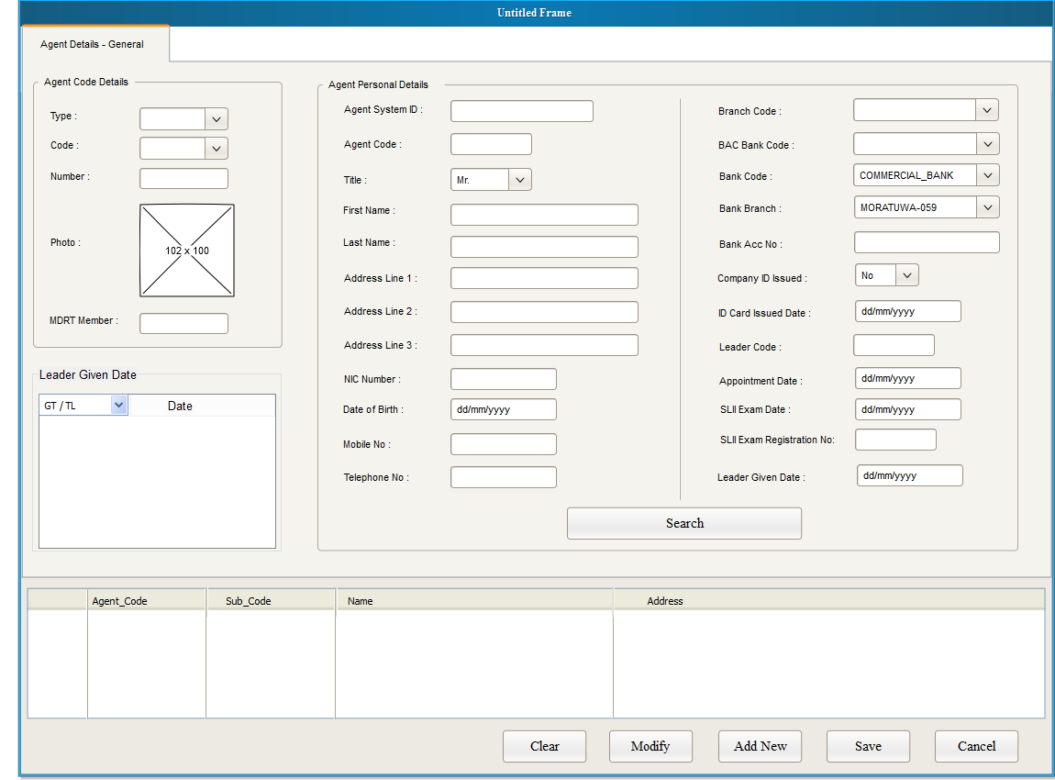

* + - * 1. Agent Other Details

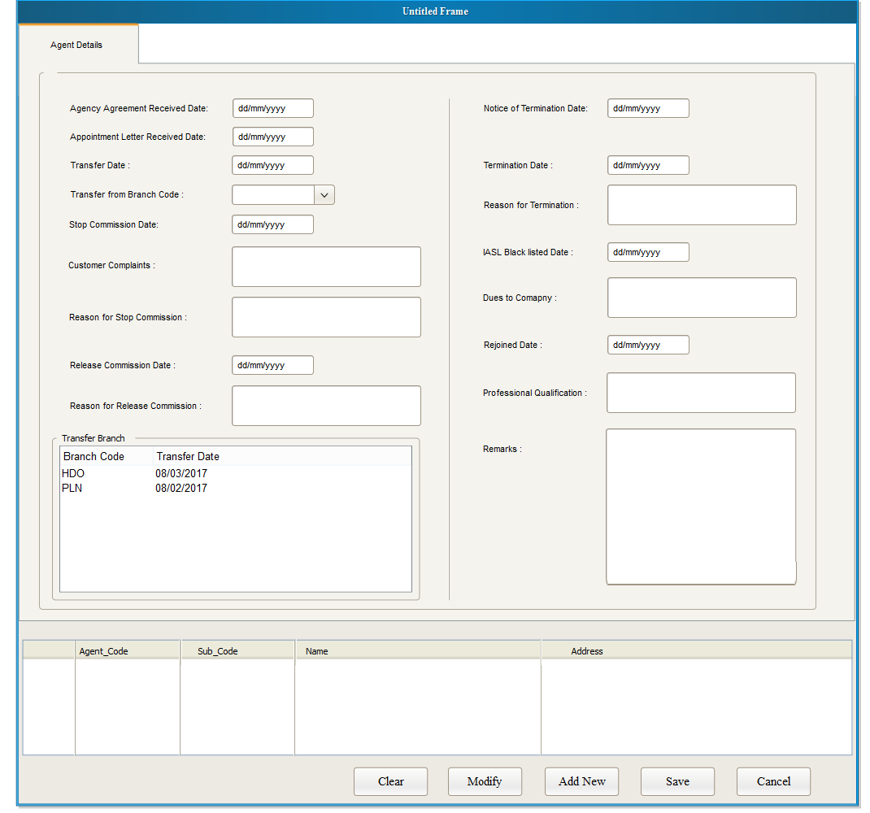

3.2.1.2.3. Agent Level Details

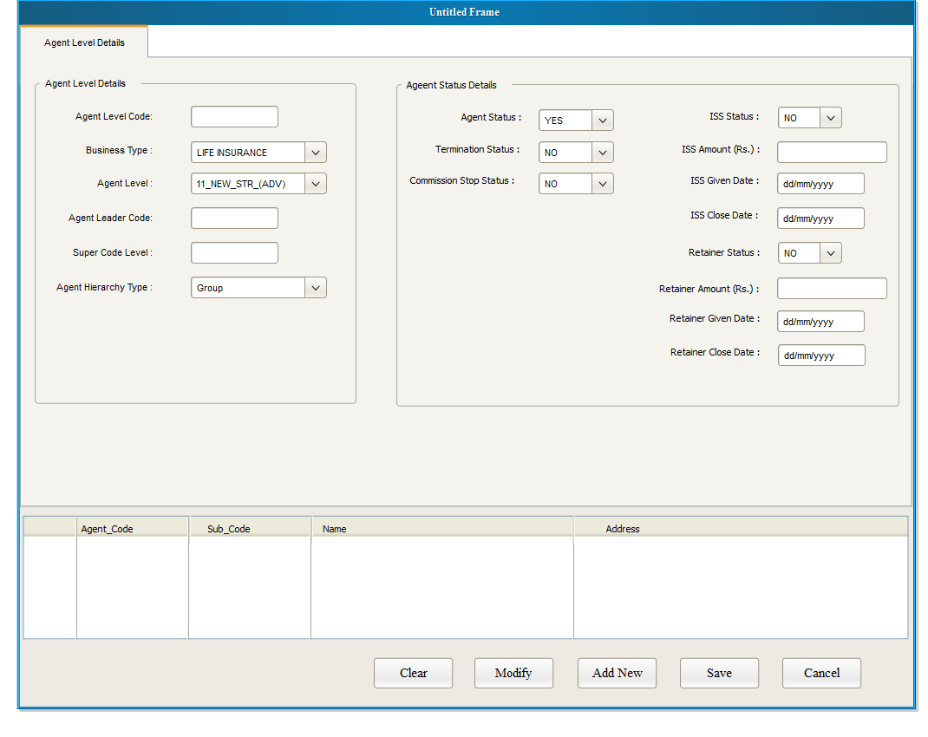

Interface 03 – Document upload and viewer

3.2.1.2.4. Commission Rule Define Interface

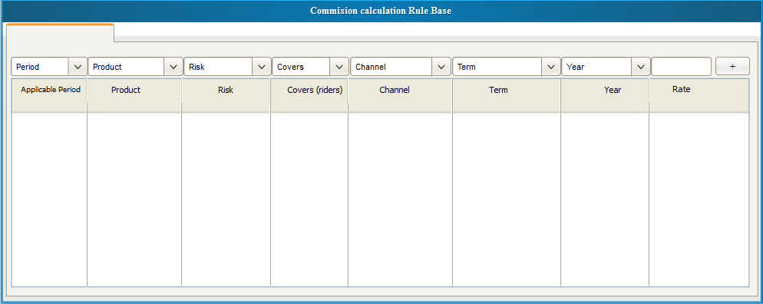

3.2.1.2.5. Commission Overriding Rule Define Interface

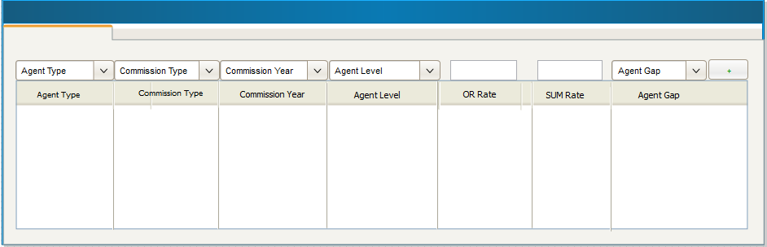

**3.3.** Reports

Servicing unit reports List - (Date Range)

1. Commission Admin Expense GWP NON BAC
2. Commission Admin Expense GWP BAC
3. Cheque Returns Report
4. Refund Report
5. Main Data Base Report
6. Main Data TME
7. PID Life
8. NONBAC Advisor Commission statement
9. TME Commission Statement
10. Transfer Summery
11. BAC Advisor commission statement
12. Opening Balance Statement
13. Refund / Cheque Return Schedule

Marketing Reports List

1. Advisor  Direct team report
2. Advisor Group  team report
3. Advisor main report
4. Advisor  report with date range
5. Policy report with date range  (Branch MIS)
6. Mobile numbers List
7. Title Mr./Mrs.- List from Gender
8. Stop commission reason List
9. Termination reason  List
10. Black list details List
11. Recoveries List
12. Preference Language

## 3.4. Other System Data

## 

This system is working based on TCS data and few other systems. This will be calculating the agent commissions and incentives by taking TCS receipts (sys vouchers) & other systems DPTS details.

Start

Get MRP/MCR DPTS

Get My Pension DPTS

Get Super Five DPTS

Get Investment DPTS

Get Takaful DPTS

Get My freedom DPTS

Check matching Receipts

Commission calculation with transaction codes (FST/FYP/RNW)

Update PID Balance

End

## Unsolved issues

1. TCS APIs is pending for to integrate New Commission app and TCS agent module.
2. Pending reports formats.

## Assumptions

* TCS will be providing APIs for **real time** communication with Agent management module so that we would be able to avoid duplicate agent detail feeding such as,
  + New advisor code entry
  + Advisors reinstate
  + Team reallocation (leader code change)
  + Bank Account details changes
  + Advisors’ Branches change
  + Advisors’ demotion details
  + Advisors’ basic details changes
  + Advisors’ status changes (Stop and Release Commission etc.)
* Cover level (Rider Level) commission will be calculating same as overriding commission calculation process since this is for extra covers and payment goes as an additional commission.
* For Non-TCS products, Until they come to systems (Applications) we have to continue the same process as now.(Upload DPTS files to new commission application)
* Please note that given interface designs may change when the time of implementation so please use those only for understanding purpose. Also For the incentive scheme there are no interface designs and flow charts given and there are more interfaces will be there more than attached.
* Reports Formats and all will be getting from the respective units.

## Annexures

|  |  |  |  |  |  |
| --- | --- | --- | --- | --- | --- |
| **Responsible For** | **Name** | **Designation** | **Recommended/**  **Approved** | **Date** | **Signature** |
| Agent Management & Incentive System | Mr. Nishantha Dissanayake | Executive – Life Distribution | Recommended |  |  |
| Agent Management & Incentive System | Mr. Pathum Fernando | Executive – Life Distribution | Recommended |  |  |
| Agent Management & Incentive System | Mr. Tharindu Munasinghe | Assistant Manager  -  Distribution | Recommended |  |  |
| Commission System | Mr. Harshana Aponsu | Manager –  Life Supporting Service | Recommended |  |  |
| BA Incentive System | Mr. Ranjeewa Gunawardena | S. Executive  -  Distribution | Recommended |  |  |
| BA Incentive System | Mr. Madhawa Gunarathne | Manager Banc assurance | Approved |  |  |
| Commission System | Ms. Geethani Saram | Head of  Life Supporting Service | Approved |  |  |
| Overall System | Mr. Ivan Nicholas | Chief Business Officer | Approved |  |  |
|  |  |  |  |  |  |